|  |  |  |  |
| --- | --- | --- | --- |
| **Criteria** | **%** | **Functio**  **nality\*** | **Quality of the**  **implementation** |
| **1) Cloud Firestore DB Design and Implementation** (including Repositories) | 60 | 100% | Works fine |
| **2) Manage static data using local SQLite** (including Repositories) | 20 | 100% | Everything works |
| **3) Signup and Signin using Firebase Authentication** | 10 | 100% | working |
| **4) Design and Testing Documentation**   * Firestore database schema diagram and SQLite database schema diagram. * Testing documentation: with evidence of working implementation using snapshots illustrating the results of your solution testing (you must use the provided template). | 10 | 100% | excellent |
| 6) **Discussion of the project contribution** of each team member [-10pts if  not done] |  | 100% | done |
| **Total** | 100 |  |  |
| Copying and/or plagiarism or not being able to explain or answer  questions about the implementation | - 100 |  | none |

# Project Documentation & Screenshots

Login and Dashboard Screenshot:

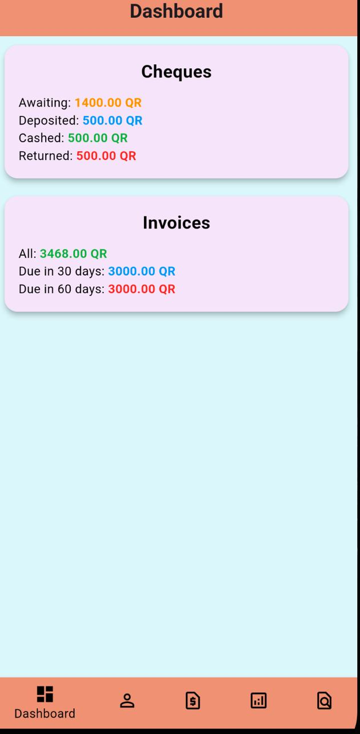

Customer Screenshots:

Cheque Screenshot:

Invoices and Payment Screen shot:

